Documenting the Truth: History through a Lens

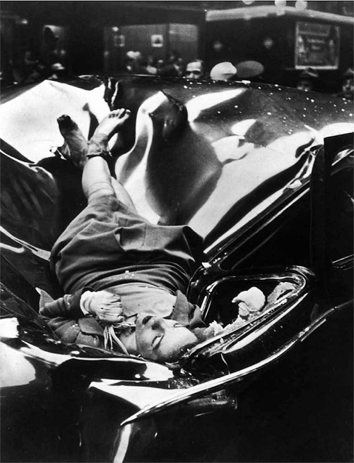
The woman’s hair is a puppet to the wind; it beats her face and then pulls back like a swaying flag. Yet she does not so much as raise her hand to tuck the dancing strands behind her ear. Standing on the eighty-sixth floor of the Empire State Building she simply gazes down. Cars honk and people rush as they do at the start of a day. The woman is unfazed and adjusts the bag she placed on a wall. She closes her eyes and furrows her eyebrows. The creases across her forehead seem to age her. She sucks in a breath, her lungs tasting air one last time. She jumps. Her body lands atop a car. The creases on her face smooth out. Her legs have delicately crossed at the ankles. She softly clutches her pearl necklace and appears to be in a deep sleep. The only reminder of the fall is the body of the car; it has reshaped itself to frame the woman. It is the year of 1947 and this is how Evelyn McHale is immortalized: through the photograph of her death.

As with the portrait of Evelyn McHale, one can separate the instant, which captures what is seemingly a beautiful girl in a slumber, from its mournful context. But while one may simply enjoy the surfaces portraits in a photographic essay offer, are they credible at serving the bigger goal of preserving history? Portraiture, as defined by The Columbia Encyclopedia, is “the art of representing the physical or psychological likeness of a real or imaginary individual”. Yet, this definition need not be limited to consider only individuals. A metaphorical portrait can result from capturing the likeness of a collective community. Thus, a portrait may depict not one human but a group. In Borrowed Dogs, portrait artist Richard Avedon is keen to show the limitations of portraits with regards to truth-telling; to him, a portrait only offers a surface to work with and the quality of its truth value is often reduced by elements of performance. Yet, even at best, portraits merely provide a surface to build upon and cannot be used to gain a deep understanding of what they capture (Avedon 2). Despite Richard Avedon’s claims that costumes and props, and a language of gestures build non-true performances in portraits, these very characteristics may be deployed in photo-essays to strip away superfluities and effectively document life.

By entering houses that make temporary homes and showcasing dusty land and crops, by capturing faces and facelessness, and by depicting stillness and movement, Larry Towell’s photo-essay “A Different Century” walks us through moments experienced by migrant Mennonites and serves as an example of a photo-essay that can efficiently record history. “A Different Century” comprises a single page of text followed by twelve black and white photographs, with only the first appearing in portrait orientation. The Mennonite women hide their faces as they clutch their hats to walk through a storm; they again conceal their faces as they smoke. In fact, their faces are not discernible in any photograph that solely features females. Another photograph comprises only Mennonites’ produce: their children play in a mess of their grain. Raising crops and children: a permanent feature of Mennonite lives even if they move from house to house on different colonies. A poor Mennonite family stands in front of a brick house. The roof has blackened with time and garbage litters around the building. In another photograph a man and a woman speed away in a car — their blurred faces highlighting migration. In the last photograph four people form a cycle of movement. A standing figure is proceeded by a sitting one; the next figure appears on his knees ready to take action. The central figure stands on a single hand. Of course, for a group cut off from the world both by choice and the barrier of language, it is no surprise than Mennonites learn from one another. In addition, the varying ages and the working towards the final motion suggest how young Mennonites who haven’t partaken in the migration are still groomed into the lifestyle led by their forefathers.

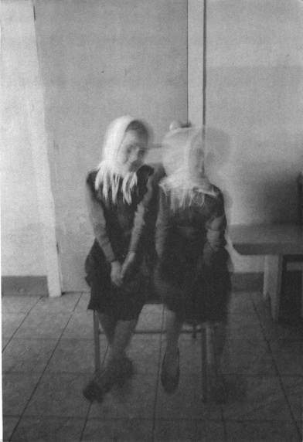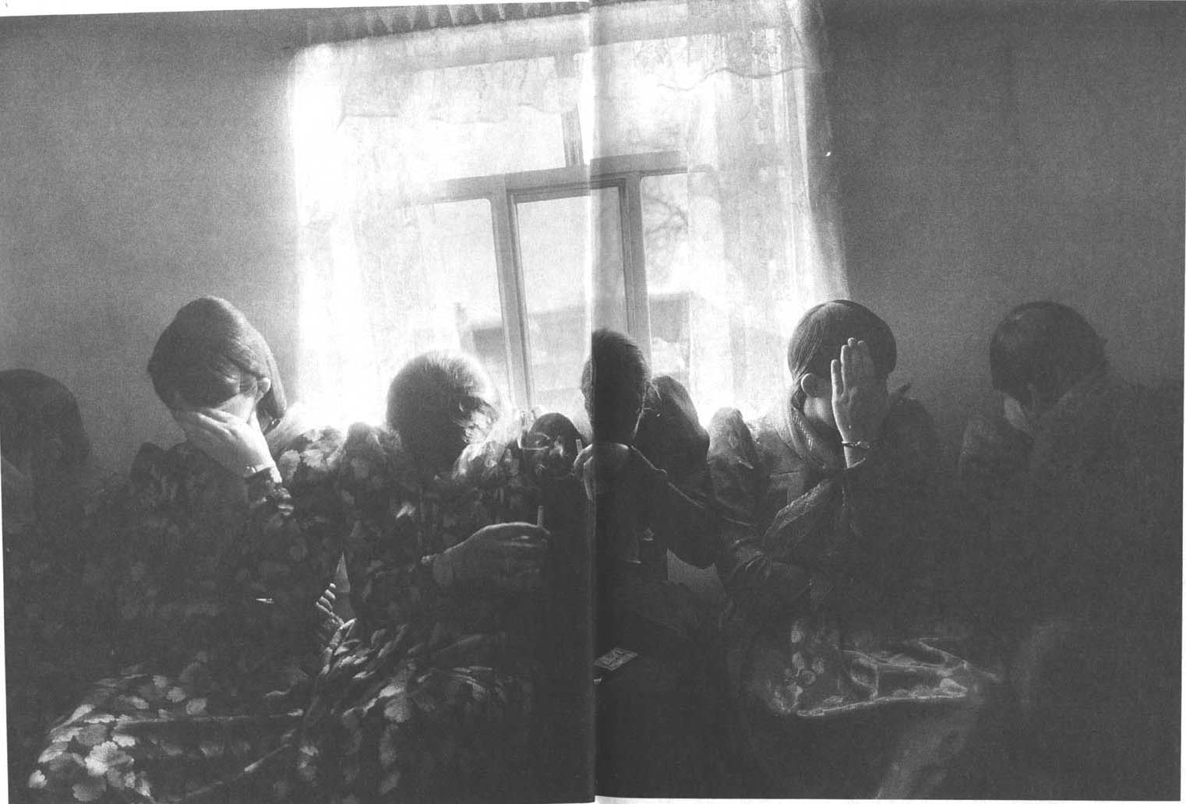
A blurry photograph is often considered a bad photograph for it fails to convey what the lens could have otherwise shown. “A Different Century” opens with two young girls, clad in a similar dress and headscarf, seated next to one another. The main distinction between them is the blurring of one’s face. While a blur is commonly believed to withold information from the viewer, in keeping with the ideas of Richard Avedon, the photograph would not have carried a truth even if the blur was omitted. The blur in discussion, infact, aids the photograph in its ability to document. Mennonites live amongst themselves and infact wish to remain apart from the world. Much like the child whose head nearly disappears in the photograph, Mennonites withdraw from the ways of the world that surrounds them. This photograph is not the only instant where a face is concealed from the viewer. Another photograph shows six women who shield their faces with their hands as they smoke. First, in addressing whether an aspect such as blurring reduces an image’s truth value we must acknowledge the fact that this image also conceals the same nature of information. Yet one does not mistrust it in a similar manner. Is blurriness what reduces an image’s truth value or is it one’s initial failure to read a complex photograph? Before measuring the capability of portraits as documetary, we must remember to be cautious to conditioned biases such as that against a blurry photograph. In addition, Richard Avedon talks about the “language of hands”. He builds a logical argument about how, in life, movements proceed thought and precede words . He argues that this does not translate into paintings for a portrait does not merely immortalize one gesture in a sequence of many (3). However a camera does not always fall victim to the constraints a painting does. Here, the response of these smoking women to conceal their faces as a camera lands upon them might have been instinctive. One can draw many inferences from this action and while those are debatable, one thing is crystal: the photograph creates room for such inferences. Carefully drawn inferences, then, do inform us about a part of the behaviour of Mennonites. Arthur Lubow in Documentary Art points to how “a great photograph is suggestive but not dispositive” (4). In keeping with Lubow, an ambiguous photograph, with plenty of room for doubts and lesser definitive narratives, makes for a good documentary-style photograph. The doubts created by the blurred and concealed faces let us work with more than the obvious surface; they allow us to learn beyond the performance.
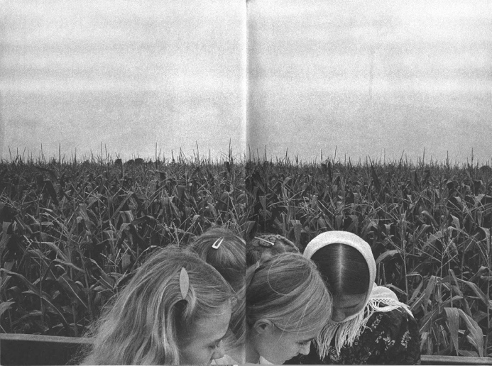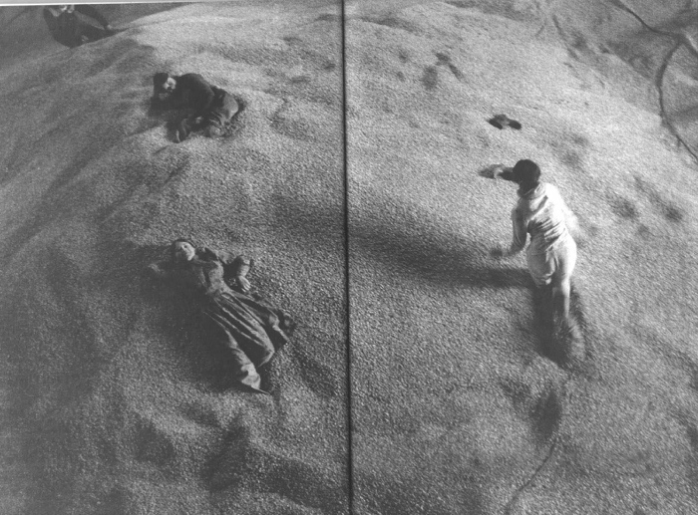
When a photograph captures the heads of Mennonite children backed by the heads of crops, these crops are not Avedon’s borrowed dogs that painted a fictious picture about the way his family desired to be (Avedon 1). Agriculture and farming are straightforward truths about the Mennonite lifestyle. In addition the prop here, i.e. the crops, does not merely facilitate the subjects in some manner. Rather, it the very juxtaposition of these two kinds of heads that establishes a point. It speaks of the simple lives lead by the Mennonities: rearing chidlren and raising crops. At another instance, when Mennonite children play in the grain their parents nurtured, the photograph holds both children and crops as vital parts of Mennonite lives; the essential part of one’s life is no performance. At the same time these photographs contain no aphorism nor do they force one decisive meaning but rather, are merely suggestive of the themes discussed above. As Arthur Lubow would agree, the success of Towell’s photo-essay at being documentary style lies in the fact that it merely nudges us in the direction where certain concepts enter our head; as with text, here, one’s ability to place trust in the truth value of the data comes from the mental space these photographs afford for one to draw a conclusion. In not drilling his intention home, Larry Towell leaves enough room for the reader to decide; hence his work comes off as credible. If his position is one that promotes ambiguity, how does the data still inform us about the Mennonities? The reason “A Different Century” is successful as a documentary even so is because it does not show these people slowing down or enjoying a scenic view with those they deem outsiders. In portraying the Mennonities in their natural setting, performing the tasks they normally would, the data does documentary work.

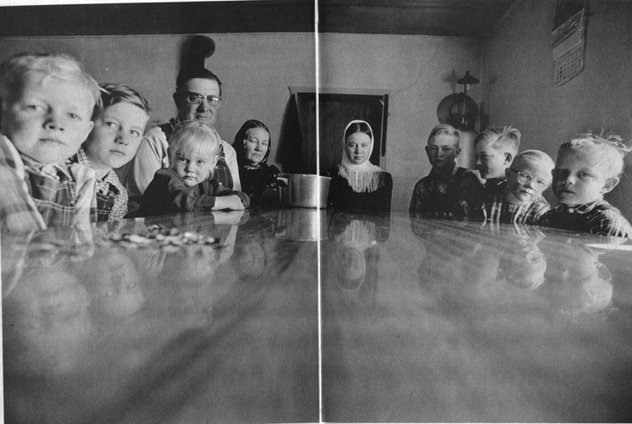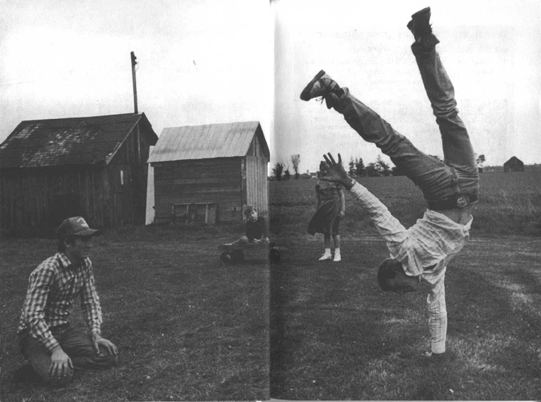
Reflections only paint a fleeting image: one that isn’t to stay. Can a photograph be any further from the truth than by having half of it made up by a reflection? Like any good piece of writing this photograph calls for a closer reading, While Avedon would argue that these frills add to an overly-stylized performance (4), Larry Towell demonstrates that they actually dissolve the performance by aiding a reading for greater meaning. It is not as if the photographer is oblivious to the doubts the reflection would arouse; rather he shows awarness that doubts are neccessary for they inspire a mistrust that helps one to read closely with a watchful eye. Regarding the reliability of this photograph as a documentary, it does convey truths about the people it represents. Some are close enough to the surface that even Avedon would consider them plausible. For instance, in this individual photograph, presenting a large family and children that, for the most part, dress similarly (as also seen in the first photograph) indicates on a larger scale that these are regular features of Mennonite families. Yet the power of the documentary is greater than that. The large number of children indicates that Mennonites choose to have a bigger family; after all, it means greater help for a migrant group relying on farmning. A calendar hangs from a wall to the photograph’s right; it shows wear and tear establishing it as useful object to the family. It is a utility to farmers. While in this photograph it is the reflections that encourage mistrust, in another photograph this emotion is caused by timing. The photograph shows a man balanced on one hand. However without the presence of a camera this moment would not serve as the epitome of stability. Hence a possible failure or — at the very least — a moment of mediocrity is captured as a great achievement. However, in Larry Towell’s defense, this isn’t a moment where a photographer morphs the truth. This photograph speaks to a natural consequence of photography, which may address the fraction of a second it captures. This is an inherent shortcoming of photography, one that a photographer need not work against but a reader must show awareness of. Once registered, this consequence simply exists; it neither adds nor takes away from the capacity of “A Different Century” as a documentary. However the photograph as a whole does add to this work’s ability as a documentary; it shows the activities that make up the free time of these people: their simple entertainment. It shows how, for Mennonites, who it would seem prefer to resemble each other in every way, enjoyment is derived from extraordinary beats produced within their community.

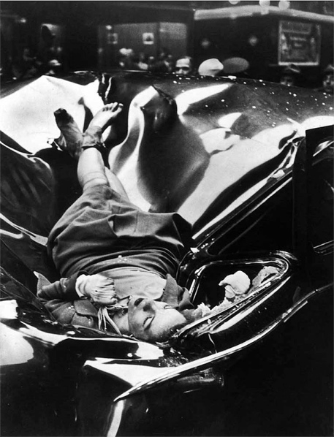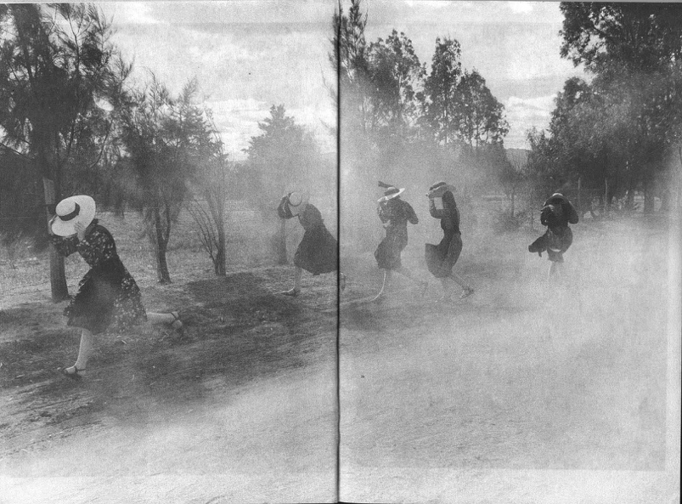
Think back to the portrait of the deceased woman; Evelyn McHale’s death is aestheticized to this date. There is nothing beautiful about tragic deaths, yet hers is often referred to as “The Most Beautiful Suicide”. Even at the scene of murder, even in the face of a situation a photographer did not control, the results are sometimes far from what can be called a documentary. The sleep-like quality of McHale’s expression wishes attention away from the most important thing about the photograph: this is a dead woman. With a community such as the Mennonites — exotic for outsiders — Towell was in a much better scenario to have created a set of images that were highly aesthicized. Yet, he did not beautify their struggles or tragedy or simplicity. In “A Different Century” a photograph shows five women huddled together as they journey by a horse; in another photograph they stumble about through the confusion of a dust storm. Unlike the image of Evelyn McHale, these photographs do not beautify the women’s struggles or confusions in the face of a storm. They simply capture Mennonite women journeying away from a dusty landscape and document the theme most releveant to Mennonites: migration. Thus, it is the choice of the photographer to portray truth through a photograph rather than beauty; a choice evident in Towell’s work.

The photographic essay is still young enough for strong doubts to surround it (Mitchell 321). Its freshness also means that its readers are still learning too. It has the ability to both present an honest truth and to cleverly alter it. However one must acknowledge that this is true across all mediums. As a documentary, the photo-essay has greater ability at offering a universal truth than text (where one’s imagination can potentially alter what is depicted). The photo-essay has its limitations: the minute time it represents, the possibility of a photographer’s voice overpowering that of the photographed, and the risk of conveying nothing but an abstract idea. Yet even these can be recognized, worked around, and omitted. Used correctly, the photographic essay documents the world and records history.

Works Cited

Towell, Larry. “A Different Century”.
Avedon, Richard. Borrowed Dogs.
Lubow, Arthur. Documentary Art.
Mitchell, W.J.T. Picture Theory.
Wikipedia contributors. "Evelyn McHale." Wikipedia, The Free Encyclopedia.

*With the exception of the portrait of Evelyn McHale (taken from the last source cited), all photographs are from “A Different Century” by Larry Towell.

